MS SQL SERVER
Standard Operating Procedures
(SOP)
Trouble shooting SQL Server 2014 Failover Cluster

Submitted to



By



CIS, Wipro Limited

Document Details

Project Name | Innogy SE
Account | CIS
IT Component/Application Title | SQL Server 2014 Failover Cluster
Current Version | 1.6
List of Contributors | Pradipkumar Kansara, Kiran Bhalekar, Ayushi Gautam, Sivakumar Goud, Pramod Patil
Customer Contact Information

Version History
(All revisions made to this document must be listed in chronological order. All revisions must be approved. Review and Approval can be done by an internal source or by the customer)
Version | Date of Revision | Description | Author | Reviewed By | Approved By
1.0 | 29-08-2015 | Initial Draft | Ayushi Gautam | Pradipkumar Kansara | Mahesh Keshatwar
1.1 | 04-09-2015 | Document Completed | Ayushi Gautam | Pradipkumar Kansara | Mahesh Keshatwar
1.2 | 21-08-2016 | Updated document to standard format | Kiran Bhalekar | Pradipkumar Kansara | Mahesh Keshatwar
1.3 | 17-05-2017 | Wipro and Innogy Logo changed | Siva Kumar Goud | Pradipkumar Kansara | Mahesh Keshatwar
1.4 | 18-08-2017 | Updated document to Wipro Standard format with header and footer | Ayushi Gautam | Pradipkumar Kansara | Santosh Badiger
1.5 | 06/12/2017 | Updated Document with SQL Server 2014. | Sivakumar Goud | Pradip Kumar Kansara | Santosh Badiger
1.6 | 10-12-2018 | Updated the content | Pramod Patil | Pradipkumar Kansara | Santosh Badiger

TABLE OF CONTENT

1. Purpose 1
2. Scope 1
3. Sql Server 2014 Failover Clustering 1
3.1 SQL Server Virtual Server Components 2
3.1.1 SQL Server Virtual Server Management Tools
3.2 Single-Instance Cluster 4
3.3 Multiple-Instance Cluster 4
4. How Failover Clustering Works 5
5. Troubleshooting Sql Server 2014 Failover Clusters 6
5.1 Service Level Agreements 6
5.2 First Step 7
5.3 Repairing A Single Node Failure And Quorum Disk Failure 7
5.4 Multiple Node Failure 8
5.5 Rebuilding The Master Database In A Clustered Environment 10

Purpose
This document is prepared for Trouble shooting SQL Server 2014 Fail over Clusters in SQL Server Database Administration Services at <Customer Name>.

Scope
This document is prepared for GSMC Wipro sustenance team and provides the concepts of Trouble shooting SQL Server 2014 Fail over Clusters in SQL Server for the administration of the SQL Server database at <Customer Name>.

SQL Server 2014 Failover Clustering
SQL Server 2014 Failover Clustering is the leading option as a primary method to achieve high availability for your databases. It offers full transactional consistency, and a failover to other another node that is automatic. By eliminating single points of failure both at the software and at the hardware level and with the proper processes and disaster recovery plans in place, you may be able to achieve five nines of availability.

SQL Server 2014 virtual server illustration
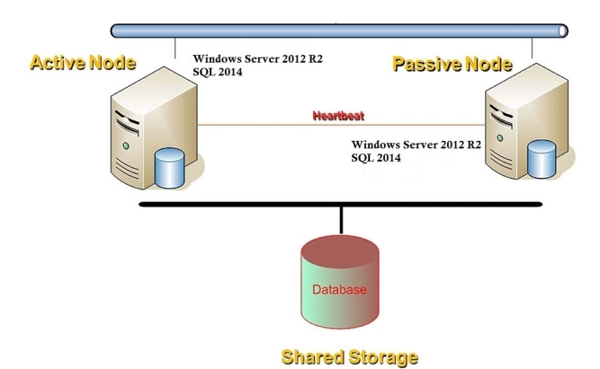
The above example is comprised of two server nodes, and one SQL Server 2014 virtual server.

SQL Server 2014 Virtual Server Components
An instance is an installation of SQL Server that is completely separate from any other, with a few underlying shared components that affect how SQL Server 2014 works in a clustered environment. A SQL Server virtual server is an instance of SQL Server that has been clustered.
The following resources make up each virtual server:
- SQL Server Network Name
This is the name that users and applications will use to connect to SQL Server.
- SQL Server IP Address
The TCP/IP address that users and applications will use to connect to SQL Server. This is different from the Cluster IP Address
- SQL Server
This controls this instance of the SQL Server 2014 service.
- SQL Server Agent
This controls this instance of the SQL Server Agent service.
- Microsoft Distributed Transaction Coordinator (MS DTC)
Some installations of SQL Server utilize MS DTC. If this is the case for your installation, MS DTC is shared for all instances in the cluster.
- SQL Server Virtual Server Administrator Account
This is the SQL Server service account.
- SQL Server Database Engine
SQL Server Database Engine includes the Database Engine, the core service for storing, processing, and securing data, replication, full-text search, tools for managing relational and XML data, and the Data Quality Services (DQS) server.
- Analysis Services
Analysis Services includes the tools for creating and managing online analytical processing (OLAP) and data mining applications.
- Reporting Services
Reporting Services includes server and client components for creating, managing, and deploying tabular, matrix, graphical, and free-form reports. Reporting Services is also an extensible platform that you can use to develop report applications.
- Integration Services
Integration Services is a set of graphical tools and programmable objects for moving, copying, and transforming data. It also includes the Data Quality Services (DQS) component for Integration Services.
- Master Data Services
Master Data Services (MDS) is the SQL Server solution for master data management. MDS can be configured to manage any domain (products, customers, accounts) and includes hierarchies, granular security, transactions, data versioning, and business rules, as well as an Add-in for Excel that can be used to manage data.

3.1.1 SQL Server 2014Virtual Server Management Tools
- SQL Server Management Studio
SQL Server Management Studio is an integrated environment to access, configure, manage, administer, and develop components of SQL Server. Management Studio lets developers and administrators of all skill levels use SQL Server.
- SQL Server Configuration Manager
SQL Server Configuration Manager provides basic configuration management for SQL Server services, server protocols, client protocols, and client aliases.
- SQL Server Profiler
SQL Server Profiler provides a graphical user interface to monitor an instance of the Database Engine or Analysis Services.
- Database Engine Tuning Advisor
Database Engine Tuning Advisor helps create optimal sets of indexes, indexed views, and partitions.
- Data Quality Client
Provides a highly simple and intuitive graphical user interface to connect to the DQS server, and perform data cleansing operations. It also allows you to centrally monitor various activities performed during the data cleansing operation.
- SQL Server Data Tools
SQL Server Data Tools provides an IDE for building solutions for the Business Intelligence components: Analysis Services, Reporting Services, and Integration Services.
- Connectivity Components
Installs components for communication between clients and servers, and network libraries for DB-Library, ODBC, and OLE DB.

With instances, come two new concepts for failover clustering:
- Single instance cluster: replaces an active/passive cluster. A single instance cluster means there is one SQL Server 2014 virtual server installed.
- Multiple instance cluster: replaces an active/active cluster. A multiple instance cluster is one in which there is more than one SQL Server 2014 virtual server installed.
- Single-Instance Cluster
A single-instance cluster has only one active instance of SQL Server owned by a single server node, and all other nodes of the cluster are in a wait state. Another node is enabled in the event of a failure on the active node, or during a manual failover for maintenance.
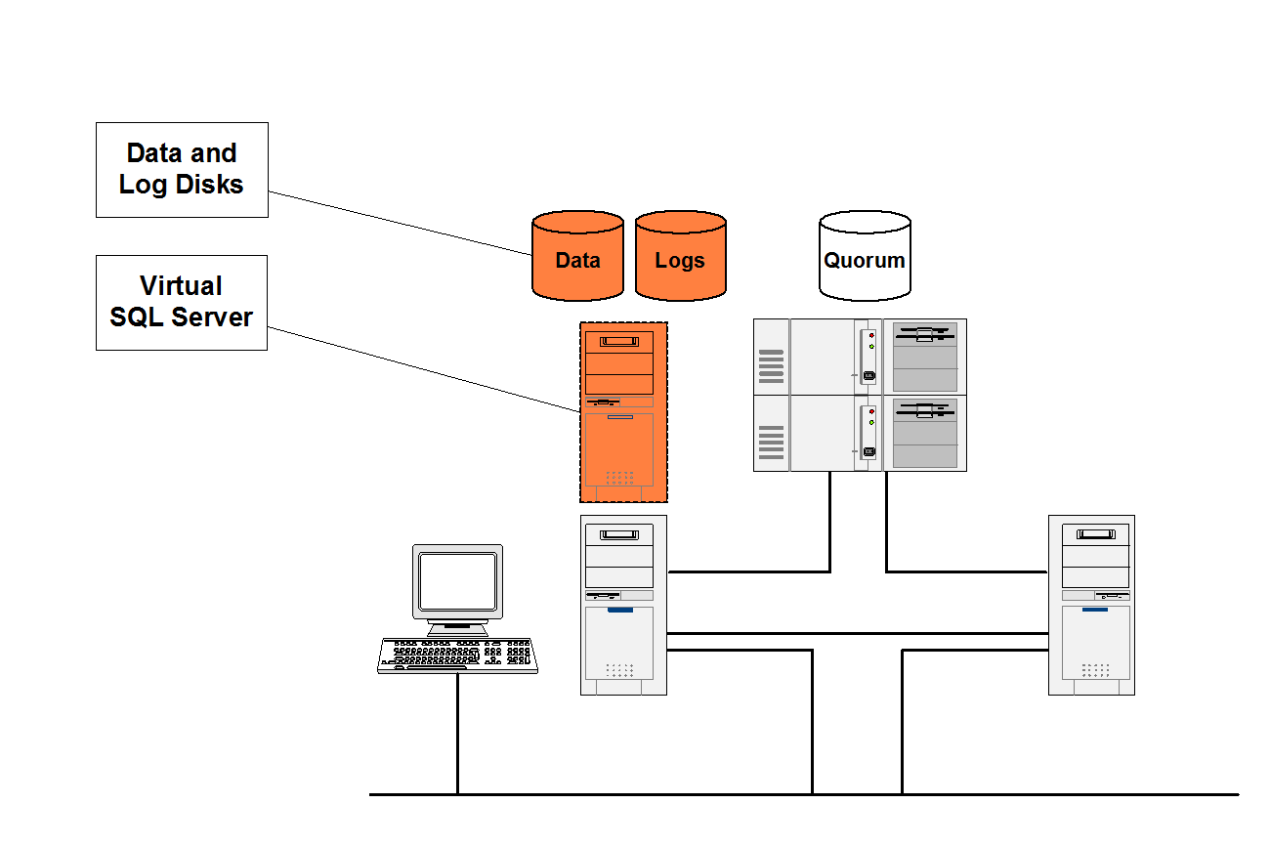

Multiple-Instance Cluster
Multiple instance cluster replaces an active/active cluster. A multiple instance cluster is one in which there is more than one SQL Server 2014 virtual server installed. Each SQL Server 2014 virtual server requires its own disk resources that cannot be used by other instances. These disk resources are the logical drive names (for example, drive F:\) used by SQL Server on which to store data and log files. Separate physical disk sets are needed to make up the logical drive, unless your disk subsystem supports multiple logical drives on one physical drive set. SQL Server in a clustered environment also behaves differently from a stand-alone named instance in relation to IP ports. During the installation process, a dynamic port that may be something other than 1433 is configured, and that port number is reserved for the instance. In a failover cluster, multiple instances can be configured to share the same port, such as 1433, because the failover cluster listens only to the IP address assigned to the SQL Server virtual server, and is not limited to a 1:1 ratio. However,
for security and potentially increased availability, you may want to assign each virtual server to its own unique port of your choice or leave it as it was configured during installation.
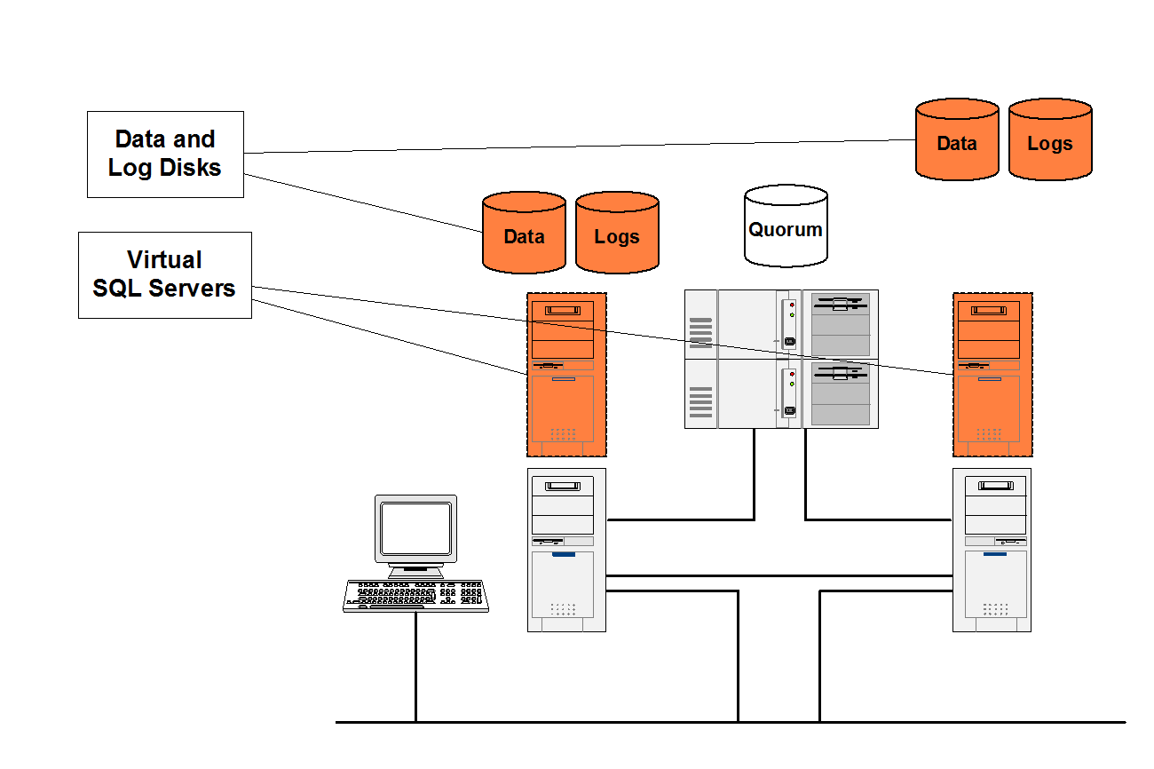

How Failover Clustering Works
The clustered nodes use the heartbeat to check whether each node is alive, at both the operating system and SQL Server level. At the operating system level, the nodes in the cluster compete for the resources of the cluster. The primary node reserves the resource every 3 seconds, and the competing node every 5 seconds. The process lasts for 25 seconds and then starts over again. For example, if the node owning the instance fails due to a problem (network, disk, and so on), at second 19, the competing node detects it at the 20-second mark, and if it is determined that the primary node no longer has control, the competing node takes over the resource.
From a SQL Server perspective, the node hosting the SQL Server resource does a looks-alive check every 5 seconds. This is a lightweight check to see whether the service is running and may succeed even if the instance of SQL Server is not operational. The Is Alive check is more thorough and involves running a SELECT @@SERVERNAME Transact SQL query against the server to determine whether the server itself is available to respond to requests; it does not guarantee that the user databases are up. If this query fails, the Is Alive check retries five times and then attempts to reconnect to the instance of SQL Server. If all five retries fail, the SQL Server resource fails. Depending on the failover threshold configuration of the SQL Server resource, Windows Clustering will attempt to either restart the resource on the same node or fail over to another available node. The execution of the query tolerates a few errors, such as licensing issues or having a paused instance of SQL Server, but ultimately fails if its threshold is exceeded.
During the fail over from one node to another, Windows clustering starts the SQL Server service for that instance on the new node, and goes through the recovery process to start the databases. The fail over of the SQL Server virtual server will take a short time (probably seconds). After the service is started and the master database is online, the SQL Server resource is considered to be up. Now the user databases will go through the normal recovery process, which means that any completed transactions in the transaction log are rolled forward, and any incomplete transactions are rolled back. The length of the recovery process depends on how much activity must be rolled forward or rolled back upon startup. Set the recovery interval of the server to a low number to avoid long recovery times and to speed up the failover process.

Troubleshooting SQL Server 2014 Failover Clusters
Troubleshooting SQL server 2014 in a failover cluster configuration is not always the same as diagnosing problems on a standalone server. First, you need to verify that the hardware, operating system, and windows clustering are all functioning properly. Then, if all of those factors are in good health, turn to Sql server.

Service Level Agreements
Ensure that you have a Service Level Agreement (SLA) with your hardware and software vendors that match the level of support you expect. Because a failover cluster is usually a mission-critical production system, purchasing a SLA that guarantees a 48-hour turnaround may not be effective. The value of a support contract may be the difference between a small amount of downtime, and a very long amount of downtime. It is imperative in a production environment that a support call is placed prior to any troubleshooting, because troubleshooting may increase downtime if it is a server down situation.

First Step
Check the operating system's Event Viewer at the Application, System, and Security logs. Sometimes the problem is apparent, such as a disk or network card failure, or relevant error messages from the operating system or SQL Server may appear. Next, check the cluster logs, which are located where the system variable %clusterlog% is set (generally \\winnt\cluster). These are the files:
- Sqlclstr.log. The log for the clustered instances of SQL Server.
- Cluster.log. The main cluster log file

Repairing a Single Node Failure and Quorum Disk Failure
If a single node fails in the cluster (due to hardware failure) or the quorum disk fails, follow these steps to rebuild the node and rejoin the cluster:
- After verifying that all cluster resource groups have been successfully moved to another node in the cluster, use the SQL Server installation program to remove the node from the SQL Server virtual server definition (see the section "Adding or Removing a Cluster Node from the Virtual Server Definition" earlier in this paper for instructions). Setup should detect the lost node and automatically move it to the Unavailable nodes list.
- Evict the server node using Cluster Administrator.
- Repair the cluster node. This may require building a new cluster node or restoring from a recent backup.
- Rejoin the cluster.
- If MS DTC is used, run comclust.exe on the node.
- Rerun the SQL Server install on the node that did not have the problem. Select the evicted node from Available nodes list and add it to the Configured nodes list.

Multiple Node Failure
If more than one node fails, but not all nodes fail, repeat the preceding steps to repair all nodes. However, if all nodes fail, and the quorum cannot be repaired, you will have to rebuild all nodes in the cluster. This is why tested and frequent backups are crucial.

Rebuilding the master Database in a Clustered Environment
If the master database needs to be rebuilt in a SQL Server failover cluster, follow these steps:
- Go to the node currently owning the SQL Server resource.
- Bring the SQL Server virtual server offline using Cluster Administrator.
- Make sure the original shared installation files or the SQL Server CD are available.
- Execute rebuildm.exe. Point it to the original shared installation files Choose Windows or SQL Collation.
- After rebuildm.exe completes, verify that the resources can be brought online and they successfully fail over.
- Verify the collation by executing sp_helpsort.
These steps do not include the steps necessary to deal with user databases.. If you have a recent backup of master, you may be able to restore it at this point. If you do not, you will have to restore or attach the user databases.

